Bachelor’s thesis on macroalgae as component in biofertilizer

## Before arrival

My reason for conducting a field study for my bachelor’s thesis is probably similar, if not identical, to that of others who have done it: To see how socioeconomic and geographic conditions affect a completely different society than that of my own, and how its culture and values have consequently been shaped. Of course, it is fun to conduct a field study as a part of your programme, but the reason was fundamentally for my own personal experience. The local supervisor of the project knew a Swedish hotel owner, whose hotel we stayed at during our visit. We did not need to apply for a visa. The official language of Grenada is English, so we did not have to learn a new language (although a quick overview of the accent beforehand would have been useful). I took the vaccines for typhoid fever, cholera, and Hepatitis A and B before leaving.

## Upon arrival

My project partner and I took the first few days to explore our surroundings, taking walks (as long as the heat allowed us to) to the marina nearby and the local supermarket.

We also walked along the famous Grande Anse beach, located a few minutes from our hotel, and took some well-deserved swimming breaks. During our first week, we began sending e-mails to people who we could potentially interview for our project, while our supervisor took us to the beach where the algae had been washed ashore.

## Financials

A large majority of the products sold in the small island state of Grenada are imported, which meant that the local supermarket was, in general, more expensive than the average supermarket in Sweden. Meat products were more expensive than the plant-based protein sources, so we ate a lot of beans, chickpeas and lentils in different recipes. We often strolled around town, but the buses in the town of St. George’s cost 2.5 EC (roughly 10 SEK), while the 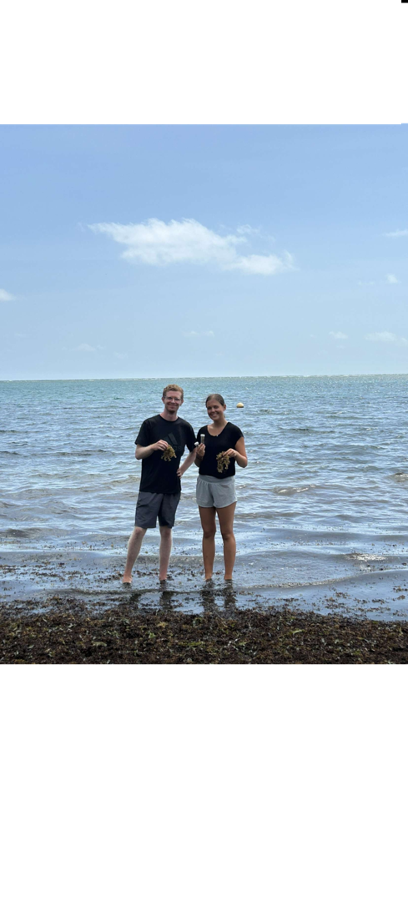buses we went with to other parts of the country cost from 3.5 to 5 EC (15 to 20 EC) depending on our destination.

## Accommodation

As previously mentioned, our local supervisor knew the owner of a hotel in the capital of Grenada. As soon as my project partner and I got the e-mail that we received the KFS scholarship, we wrote to the owner on WhatsApp and booked dates. Since we stayed there during the tourist season, it’s advisable to book the room as early as possible. We paid 270 SEK/night, for a room with a small stove, oven, fridge and freezer, and that was cleaned every second day. Additionally, we often used the hotel’s outdoor kitchen.

## Project

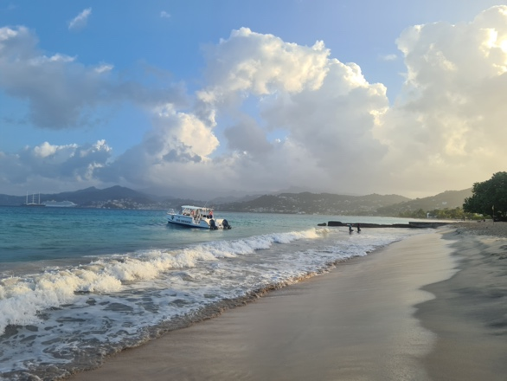Our project focused on the *Sargassum* seaweed that, in recent years, have washed ashore in large heaps during the spring and summer months in Grenada and other Caribbean nations, causing environmental, economic and health problems.

AlgaeFuel is a company aiming to utilize the seaweed for biogas production, while our project focused on evaluating the possibility of using the rest products from those reactions as a biofertilizer. We are doing a chemical analysis of the algae’s nutritional value and heavy metal content, while also doing a market analysis of the domestic fertilizer market. Our local supervisor helped us a lot by driving us to Soubise beach where we obtained most of our algae from, while also providing us with contact information to relevant actors for our project. We had meetings online, but also at their offices and locations close to St. George’s. We also obtained some algae from La Sagesse beach, a nice, peaceful beach on the east coast.

## Country

Grenada is an island country in the Caribbean, consisting of three main islands: Grenada, Carriacou and Petite Martinique. The country has around 110,000 inhabitants, with a big portion of its working population working in the tourist sector, which is not surprising. Resort after resort was lined up along the 2 km long Grande Anse beach, while rows of sunchairs were set up every morning for the tourists arriving with the daily cruise ships. The nature and landscape of Grenada was indeed worth seeing and exploring, as it proved to be the biggest source of awe for me: The trek to the great Seven Sisters Waterfalls, the countless viewpoints on the path to the top of Mount Qua Qua and the majestic clouds sweeping over the hills as I ran in the mornings on Grande Anse.

## Leisure and social activities

Our main source of leisure was mostly taking walks on Grande Anse and continuing past Quarantine Point to BBC beach, another beautiful beach with turquoise water. My project partner and I often went to play beach tennis at the Mount Cinnamon Resort (and became pretty good at it, in my opinion). Besides just swimming, we also snorkelled and each time we made it our mission to find as many sea turtles as possible.

When we didn’t work on our report, we often took the bus and visited sights on the island: the Annandale, Seven Sisters and Mount Carmel waterfalls, the Diamond Chocolate Factory in Victoria, and Mount Qua Qua, to name a few.

Lastly, a good way to explore the island is to sign up to the Hash House Harriers, a group of both locals and expats who either walk or run on different trails every Saturday. It can both be difficult and beautiful, but after the first time they’ll A bowl of food on a table
offer you a free beer.

## Sustainability

Apart from the fact that we travelled for almost 13 hours by plane, back and forth, we tried to live as sustainably as possible once in Grenada. We followed an almost completely vegetarian diet (not counting some fried chicken and tuna steaks here and there), and tried to eat as much locally sourced foods as possible, including plantain, regular and sweet potato, cantaloupe and honeydew melon, etc. The beans and corn we ate (a lot of) were imported from Trinidad and Tobago, an island country just south of Grenada. What’s more, we travelled by bus a lot of the time, the only method of collective transport on the island.

## Other recommendations and observations

I have a few suggestions and tips for any future students wanting to visit Grenada:

1. Be ready that the buses are intense, often with fast driving and loud music, but it’s an experience in and of itself. It can be bumpy, but the driver will get you to where you want to go – just tap with your knuckles on the bus window and they’ll let you off.
2. Be prepared of the possibility that lizards can sneak into your room. It happened to us more than once. They are completely harmless, but pretty difficult to get rid of unless you want another roommate.
3. A lizard on a wall

   AI-generated content may be incorrect.Go to the True Blue Bay Resort on Wednesdays to try the food of local vendors – especially the fried bakes and nutmeg ice cream, and if you’re daring, try them together. Otherwise, street food such as roti and doubles are worth a try (while the national dish oil-down can be an acquired taste).

